SCHOOL:.....

3RD TERM EXAMINATION
CLASS: Nursery I
SUBJECT: Computer INSTRUCTION: Tick Yes or No

1. Computer is an electronic machine - Yes / No
2. Monitor looks like television - yes / no
3. Keyboard is part of computer - yes / no
4. Printer is also part of computer - yes / no
5. Computer can save document - yes / no
6. Computer is a fast machine - yes / no
7. Printer print document - yes / no
8. Computer can cook food - yes / no
9. Computer can attend to customer - yes / no
10. You can read from the computer monitor - yes / no

SECTION B
- List three parts of computer that yo know
- Describe how computer looks like

SCHOOL:.....

3RD TERM EXAMINATION

CLASS: Nursery I SUBJECT: Creative Art

1. Draw a cup and colour it green

2. Draw a ball and colour it yellow

3. Draw a bell and colour it brown

4.Trace this pencil and coloured it blue

SCHOOL:.....

3RD TERM EXAMINATION

CLASS: Nursery I
SUBJECT: Moral Instruction
- Is it good to abuse our friend - yes / no
- Is it good to curse someone - yes / no
- The word “Respect” has how many letters
- 6 b. 7 c. 8
- We can slap our elders - yes / no
- We must forgive our friend - yes / no
- Word are just like an egg - yes / no
- We must watch our tongue - yes / no
- Bastard is a bad word - yes / no
- Good child must behave well - yes / no
- We must obey elder instructions - yes / no
Section b
Demonstrate how to great elder according to your sex

SCHOOL:.....

3RD TERM EXAMINATION

CLASS: Nursery ISUBJECT: Basic Science
1. ______and ______are shaper objects a. corn and bean
b. meat and fish c. blade and scissor
2. ________can be found inside the first aid box
a. well b. cotton wool c. mob
3. ________is the first treatment given to a sick person
- Third aid b. second aid c. first aid
4. ________and ________ are sources of water
River and tap water b. green and life water c. clean and dirty water
5. We use water for all these except __________
a. watering plant b. bathing c. sewing
6. Clean water must be ________to drink a. safe b. smelling c. dirty
7. All these are characteristics of safe water except _______________
a. colourless b. odourless c. white
8. We can add alum to our water___________ a. true b. false c. not sure
9. Boiling of water is one of the methods of water purification ________
a. false b. true c. no idea
10. Cholera and diarrhea is a water born disease
a. true b. false c. may be

section b

- State two insects that can cause sickness for human
- Is it good to cover our food?

SCHOOL:.....

3RD TERM EXAMINATION

CLASS: Nursery I
SUBJECT: Verbal Reasoning

1. March the word and opposite together
Up big
Man good
Bad girl
Boy down
Small woman
2. Jumbled the following words
geg = nam =
ebd = aws =
tac =
3. Re-arrange the alphabets example


SCHOOL:.....

3RD TERM EXAMINATION

CLASS: Nursery I
SUBJECT: Civil Education

1. Sweeping is part of our responsibility, at home
a. true b. false c. may be

2. Fight with our parents is _______ a. Good b. Bad c. I don’t know

3. We _________in the school a. steal b. Fight c. learn

4. We need to respect our _______a. thief b. Stranger c. teacher

5. We must go to school _______a. late b. early c. once

6. We cook in the ________a. toilet b. bedroom c. kitchen

7. A good community must ______one another
a. hate b. love c. dislike

8. ___________is part of orderliness in the community
- Disobedient b. fight c. greeting

9. _________is good in the community a. co-operation
b. stealing c. fighting

10. Cooperation in the community brings _______________
- Unity b. hatred c. disunity

Section b
- Mention two items you must return to your teacher if found in the school

SCHOOL:.....
3rd TERM EXAMINATION
SUBJECT: SOCIAL HABIT CLASS: NUR 1
Answer all questions
- We help our _______to wash plate at home (a) Teacher (b) parent
- We help our parent to wash _________ (a) clothes (b) air
- We should not _______when eating (a) talk (b) drink water
- Stand while eating is _________ table manner (a) bad (b) good
- Dirty clothes can cause _________ (a) illness (b) fighting
- Slippery from tiles is ________ accident (a) home (b) road
- We have _______major languages in Nigeria (a) 3 (b) 10
- We should _______our neighbor (a) love (b) hate
- We must live in _________with people (a) anger (b) peace
- The name of Nigeria President is ___ (a) Muhammed Buhari (b) SerikiDandaki

SCHOOL:.....
SUBJECT: MATHEMATICS CLASS: NUR 1

- H T U 2. H T U
8 4 3 0 5 7
+ 1 2 2 + 9 4 2

3. H T U 4. T U
6 3 8 1 3
2 4 1 x 2

5. T U
2 4
X 2

SCHOOL:.....
SUBJECT: HEALTH HABIT CLASS: NUR 1
- Living in dirty environment can cause illness (a) yes (b) No
- We sweep the bedroom with (a) broom (b) wiper
- We should bath _________daily (a) twice (b) once in a month
- We have _____states in Nigeria (a) 36 (b) 42
- We should brush our teeth __daily (a) twice (b) Once in 2 months
- Living in dirty environment is _____- (a) bad (b)good
- Sleeping while driving can cause accident (a) home (b) road
- Eating on the road is _____habit (a) bad (b) good
- Cutting finger with knife is ________accident (a) road (b) home
- Eating uncover food cause (a) illness (b) fat

SCHOOL:.....
SUBJECT: ENGLISH STUDIES CLASS: NUR 1
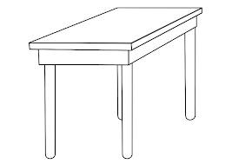
Simple sentences
1.What is this?
It is a (a) Table cup
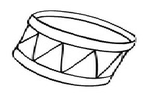
2.What is this?
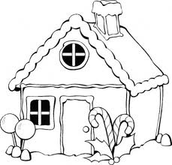
It is _________(a) basket, ball)
3.What is this?
It is a ____________(a) House, bed)
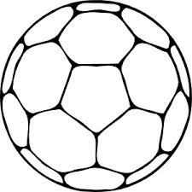
4.What is this? (ball, Chair)
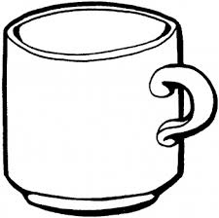
It is a _________(a) ball, cub)
5.What is this?
It is a ________
Use vowel “a” to fill the gaps
- C__t
- M___t
- C____n
- E___t
- F___n

SCHOOL:.....
SUBJECT: QUANTITATIVE REASONING CLASS: NUR 1
- 8 2. 5
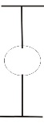


7 10


3. 4 4. 3


9 20



5. 4 6. 7

12 13



7. 24 8. 15

10 10

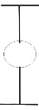
9. 10 10. 6


SCHOOL:.....
SUBJECT: C.R.S CLASS: NUR 1
- Obedience to God brings us _______ (a) hatred (b) blessing
- _______obey God (a) Abraham (b) Devil
- God created man in His own ____ (a) image (b) skin
- God is _____ [a] able [b] not able
- As Christian we must go to (a) church (b) and Abuja only
- As a Christian we must not lie against one another (a) True (b) False
- A child of Christ must not join (a) bad group (b) fellowship
- _________created everything in the world (a) True (b) False
- God can speak to us through our pastor (a) True (b) False
- It is ______to obey our parent (a) good (b) bad
Section b
- What is the name of the leader church of

SCHOOL:.....
SUBJECT: POEM CLASS: NUR 1
A lion a lion
A lion has a tail
It is a big head
And a very small west.
Two little dickies birds
Sitting on a wall
One name Peter
One name Paul
Fly away Peter
Fly away Paul
Come back Peter
Come back Paul
Oh come back little dickies birds and sit on the wall.

